#TASK1

f = open("goodDetail.csv", 'w')

for i in range(10):

    y = input("enter the name of good:")

    f.write(y)

    x = input("enter the price of good:")

    f.write(",")

    f.write(x)

    z = input("enter the expiry date:")

    f.write(",")

    f.write(z)

    f.write("\n")

f.close()

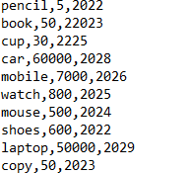

# TASK2

f = open("exam-results.txt", 'r')

d = f.read(345)

print(d)

p = open("new_result.txt", 'w')

p.write(d)

f.close()

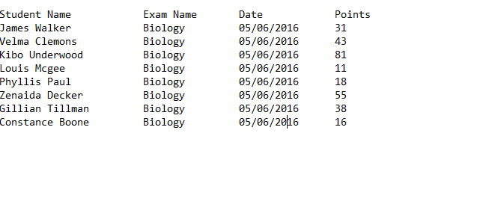

f = open("exam-results.txt", 'r')

d = f.read()

e = d.split("\n")

count = 0

for i in e:

    count += 1

print(count)

